*`*

# **MY PERSONAL WEBSITE**

In Partial Fulfillment

Of the Course Requirements in IIT406-Computer Programming 3

for the Degree of Bachelor of Science in Information Technology

Submitted to:

**Assoc. Prof. Cristina D. de los Santos**

IIT406 Professor

Submitted by:

**Quitasol, Ralph Daniel A.**

October 2022

TABLE OF CONTENTS

**MY PERSONAL WEBSITE** i

**SITE MAP** 1

**STORYBOARD** 2

Storyboard # 1: ABOUT 2

Storyboard # 2: GALLERY 3

**SCREEN DESIGN** 4

Screen Design # 1: ABOUT.HTML 4

Screen Design # 2: GALLERY.HTML 6

**SOURCE CODE** 8

Source Code # 1: ABOUT.HTML 8

Source Code # 2: GALLERY.HTML 15

**REFLECTION** 22

# **SITE MAP**

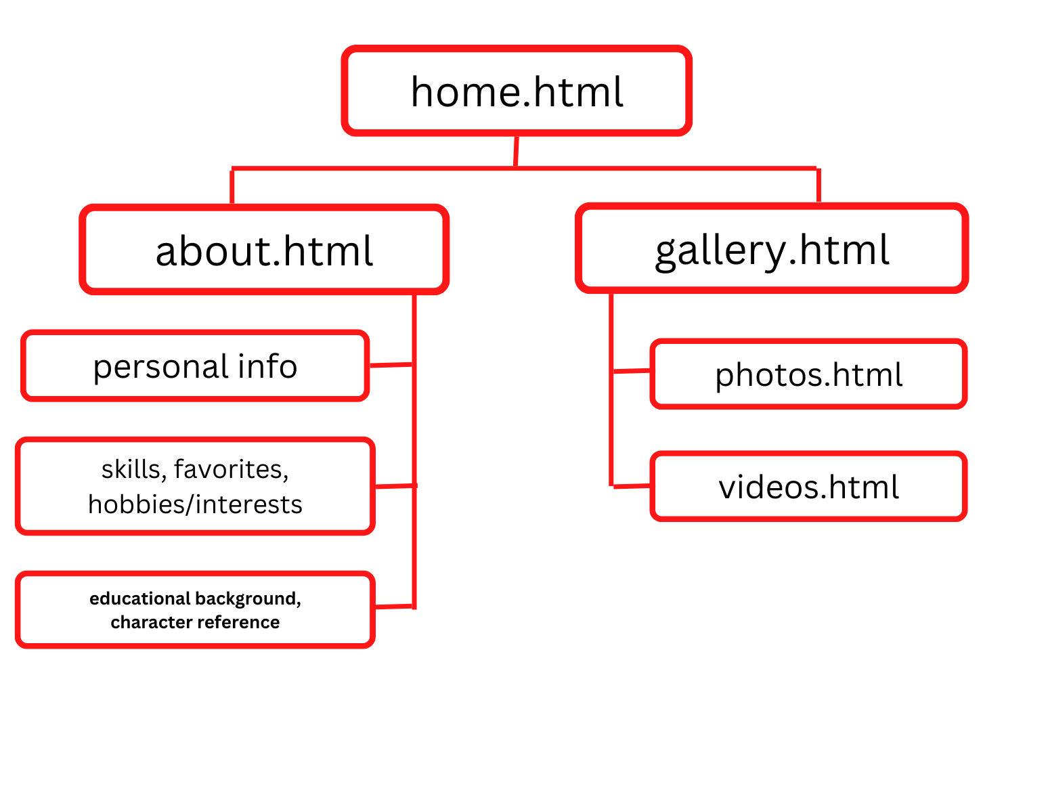

# **STORYBOARD**

## Storyboard # 1: ABOUT

**Description**: It has banner, menu, header, images, and footer. Also, used the provided layout given in the document.

**

## Storyboard # 2: GALLERY

**Description**: It has navigational bar, images for gallery style of format and singled stack for videos and footer.

**Layout**:

# **SCREEN DESIGN**

## Screen Design # 1: ABOUT.HTML

**Description**: It serves as the about section of my Personal Website. It presents the personal information/skills/interests about me and about my site the navigation bar such as Home, About, and Gallery.

**Layout**:

## Screen Design # 2: GALLERY.HTML

**Description**: Used a 3x4 layout to showcase all the different pictures in the gallery. It also has the navigation bar such as Home, About, and Gallery to navigate different webpages.

**Layout**:

# **SOURCE CODE**

## Source Code # 1: ABOUT.HTML

<!DOCTYPE html>

<html>

<head>

<title> About </title>

<link rel="stylesheet" href= "design.css">

</head>

<body>

<table style="background-color: #365194; border-bottom: none;">

<tr>

<th style="width:20%; border-bottom: none; padding-right: 10px;padding-left: 30px;">

<img src="letran-logo.png" style = 'width: 50px; height: 50px'>

</th>

<th style="text-align: left; color: white; width:40%; border-bottom: none;padding-left: 5px;">

<b> Ralph Daniel Quitasol </b>

</th>

<th style="font-size: 40px; color: white; width:40%; border-bottom: none;padding-left: 10px;">

<b> About </b>

</th>

</tr>

</table>

<ul>

<li><a href="carousel.html">Home</a></li>

<li><a href="about.html">About</a></li>

<li><a href="gallery.html">Gallery</a></li>

</ul>

<center>

<br><br><br><br>

<h2 style="font-size: 40px; color: white"> Personal Information </h2>

<table style="width:75%;">

<tr>

<td colspan='2'style='border:5px;'><a href="gallery.html" target = "_blank">

<img src="profilepic.jpg" style = 'width: 350px; height:350px;'></td>

<td style="padding: 40px">

<img src="profileicon.png" style = 'width: 50px;

height:50px;'><br><br>

<img src="addr.png"style = 'width: 50px;

height:50px;'><br><br>

<img src="phone.png" style = 'width: 48px;

height:48px;'><br><br>

<img src="mail.png"style = 'width: 50px;

height:50px;'><br><br>

<a href="https://www.facebook.com/ralphdanielq" target = "_blank"><img src="facebook.png" style = 'width: 46px;

height:46px;'><br><br>

<a href="https://www.instagram.com/ralphdanielq" target = "_blank"><img src="instagram.png"style = 'width: 50px;

height:50px;'><br><br>

</td>

<td align="left" style="font-size:20.5px; padding: 10px">

Ralph Daniel A. Quitaosl <br><br><br>

Mercy St. Cityland, Brgy. Mabuhay, Carmona, Cavite <br><br><br>

+639692460046 <br><br><br>

ralphquitasol@gmail.com <br><br><br>

@ralphdanielq <br><br><br>

@ralphdanielq <br><br>

</td>

</tr>

</table>

<br><br><br>

<table style="width:75%;">

<tr>

<th colspan="2" style="font-size: 40px; width:25%">

Skills

</th>

<th colspan="2" style="font-size: 40px; width:25%; background-color: #ddd; border-bottom: 1px solid white;">

Favorites

</th>

<th colspan="2" style="font-size: 40px; width:25%">

Hobbies/<br>Interests

</th>

</tr>

<tr>

<td><img src="iconskills1.png" style = 'width: 50px; height: 50px'></td> <!--icon skills-->

<td> Programming Languages: C, C++, Java</td> <!--skills-->

<td style="background-color: #ddd; border-bottom: 1px solid #F2F3F4;"><img src="iconsfav1.png" style = 'width: 50px; height: 50px'></td> <!--icon fav-->

<td style="background-color: #ddd; border-bottom: 1px solid #F2F3F4"> Food: Menudo </td> <!--fav-->

<td><img src="iconhob1.png" style = 'width: 50px; height: 50px'></td> <!--icon hobb-->

<td> Basketball </td> <!--hobb/int-->

</tr>

<tr>

<td><img src="iconskills2.png" style = 'width: 50px; height: 50px'></td> <!--icon skills-->

<td> Basic Troubleshooting: Hardware, Software</td> <!--skills-->

<td style="background-color: #ddd; border-bottom: 1px solid #F2F3F4"><img src="iconsfav2.png" style = 'width: 50px; height: 50px'></td> <!--icon fav-->

<td style="background-color: #ddd; border-bottom: 1px solid #F2F3F4"> Color: Blue </td> <!--fav-->

<td><img src="iconhob2.png" style = 'width: 50px; height: 50px'></td> <!--icon hobb-->

<td> Computers: Hardware</td> <!--hobb/int-->

</tr>

<tr>

<td><img src="iconskills3.png" style = 'width: 50px; height: 50px'></td> <!--icon skills-->

<td> Photo Editing: Photoshop, Canva</td> <!--skills-->

<td style="background-color: #ddd; border-bottom: 1px solid #F2F3F4"><img src="iconsfav3.png" style = 'width: 50px; height: 50px'></td> <!--iconfav-->

<td style="background-color: #ddd; border-bottom: 1px solid #F2F3F4"> Sport: Basketball </td> <!--fav-->

<td><img src="iconhob3.png" style = 'width: 50px; height: 50px'></td> <!--icon hobb-->

<td> Listening to Music </td> <!--hobb/int-->

</tr>

<tr>

<td><img src="iconskills4.png" style = 'width: 50px; height: 50px'></td> <!--icon skills-->

<td> Computer Literate: MS Word, MS Office, etc. </td> <!--skills-->

<td style="background-color: #ddd; border-bottom: 1px solid #F2F3F4"><img src="theweeknd.png" style = 'width: 50px; height: 50px'></td> <!--icon fav-->

<td style="background-color: #ddd; border-bottom: 1px solid #F2F3F4"> Music Artist: The Weeknd </td> <!--fav-->

<td><img src="iconhob4.png" style = 'width: 50px; height: 50px'></td> <!--icon hobb/int-->

<td> Computer Games </td> <!--hobb/int-->

</tr>

<tr>

<td><img src="iconskills5.png" style = 'width: 50px; height: 50px'></td> <!--icon skills-->

<td> Drawing Skills </td> <!--skills-->

<td style="background-color: #ddd; border-bottom: 1px solid #F2F3F4"><img src="kopi.png" style = 'width: 50px; height: 50px'></td> <!--icon fav-->

<td style="background-color: #ddd; border-bottom: 1px solid #F2F3F4"> Drink: Coffee </td> <!--fav-->

<td><img src="iconhob5.png" style = 'width: 50px; height: 50px'></td> <!--icon hobb/int-->

<td> Cars </td> <!--hobb/int-->

</tr>

</table>

<br><br><br>

<table style="width:75%; text-align: center">

<tr>

<th style="font-size: 40px"> Educational Background </th>

<th style="font-size: 40px; background-color: #ddd; border-bottom: 1px solid #F2F3F4"> Character References </th>

</tr>

<tr>

<td>

<img src="letran-logo.png" style = 'width: 50px; height: 50px'><br>

<b>Collegiate</b> <br>

2021-Present <br>

Bachelor of Science in Information Technology <br>

Colegio de San Juan de Letran <br>

151 Muralla St., 1002 Manila, Philippines <br>

(02) 8527 7697 <br>

</td>

<td style="background-color: #ddd; border-bottom: 1px solid #F2F3F4">

<img src="profileicon.png" style = 'width: 50px; height: 50px'><br>

<b> Assoc. Prof. Cristina De Los Santos </b> <br>

IIT405 Proffesor <br>

Colegio de San Juan de Letran <br>

</td>

</tr>

<tr>

<td>

<img src="allshs.png" style = 'width: 50px; height: 50px'><br>

<b>Senior High School</b> <br>

2019-2021 <br>

ICT - Animation<br>

Angelo Levardo Loyola Senior High School <br>

Barangay Lantic, Carmona, Cavite <br>

</td>

<td style="background-color: #ddd; border-bottom: 1px solid #F2F3F4">

<img src="profileicon.png" style = 'width: 50px; height: 50px'><br>

<b>Jenily Rodriguez </b><br>

Teacher II <br>

Angelo Levardo Loyola Senior High School <br>

</td>

</tr>

<tr>

<td>

<img src="zion.png" style = 'width: 50px; height: 60px'><br>

<b>High School</b> <br>

Zion Academy of Carmona <br>

Barangay Mabuhay, Carmona, Cavite <br>

(046) 412 6616 <br>

</td>

<td style="background-color: #ddd; border-bottom: 1px solid #F2F3F4">

<img src="profileicon.png" style = 'width: 50px; height: 50px'><br>

<b>May Magallon </b><br>

Animation NCII Teacher <br>

Angelo Levardo Loyola Senior High School <br>

</td>

</tr>

<tr>

<td>

<img src="tslc.png" style = 'width: 50px; height: 50px'><br>

<b>Elementary </b><br>

Toddlers Smart Learning Center <br>

Barangay Mabuhay, Carmona, Cavite <br>

(046) 413 0200 <br>

</td>

<td style="background-color: #ddd; border-bottom: 1px solid #F2F3F4">

</td>

</tr>

</table>

</center>

<br><br><br><br><br>

<p align="center" style="background-color: #333; width: 100%">

<font color="#F2F3F4"><br><br>For more information, please contact </font><br>

<font color="#F2F3F4"><b>Ralph Daniel A. Quitasol - IT2A </b></font><br><br>

<img src="letran-logo.png" style = 'width: 50px; height: 50px'><br>

<font color="#F2F3F4">Colegio de San Juan de Letran <br> Intramuros, Manila</font><br>

<font color="#F2F3F4">Copyright: October 2022</font><br>

<br><br>

</p>

</body>

</html>

Source Code CSS: design.css

html{

font-family: Courier New;

}

body{

background-color: #365194;

background-image: url('bground4.png');

background-repeat: no-repeat;

background-attachment: fixed;

background-size: cover;

color: #253354;

}

li {

display: inline;

float: left;

}

ul {

list-style-type: none;

margin: 0;

padding: 0;

overflow: hidden;

background-color: #333;

}

a {

display: block;

}

li a {

display: block;

color: #F2F3F4;

text-align: center;

padding: 14px 16px;

text-decoration: none;

}

li a:hover {

background-color: #111;

}

th, td{

padding: 50px;

border-spacing: 50px;

padding-right: 30px;

border-bottom: 1px solid #ddd;

}

table{

background-color: #F2F3F4;

-moz-border-radius: 5px;

border-collapse: collapse;

border: none;

}

table {

border-radius: 25px;

background: #F2F3F4;

padding: 20px;

width: 200px;

height: 150px;

}

## Source Code # 2: GALLERY.HTML

<!DOCTYPE html>

<html>

<head>

<title> Gallery </title>

<link rel="stylesheet" href= "design.css">

</head>

<body>

<table style="background-color: #365194; border-bottom: none;">

<tr>

<th style="width:20%; border-bottom: none; padding-right: 10px;padding-left: 30px;">

<img src="letran-logo.png" style = 'width: 50px; height: 50px'>

</th>

<th style="text-align: left; color: white; width:40%; border-bottom: none;padding-left: 5px;">

<b> Ralph Daniel Quitasol </b>

</th>

<th style="font-size: 40px; color: white; width:40%; border-bottom: none;padding-left: 10px;">

<b> Gallery </b>

</th>

</tr>

</table>

<ul>

<li><a href="carousel.html">Home</a></li>

<li><a href="about.html">About</a></li>

<li><a href="gallery.html">Gallery</a></li>

</ul>

<center>

<br><br><br><br><br>

<h1 align='center'style="font-size: 40px; color: #F2F3F4"> Photos </h1>

<table style="width:75%; text-align: center">

<tr>

<th>

<img src="photo1.jpg" style = 'width: 382px; height: 288px'>

</th>

<th>

<img src="photo2.jpg" style = 'width: 382px; height: 288px'>

</th>

<th>

<img src="photo3.jpg" style = 'width: 382px; height: 288px'>

</th>

</tr>

<tr>

<th>

<img src="photo5.jpg" style = 'width: 382px; height: 288px'>

</th>

<th>

<img src="photo6.jpg" style = 'width: 382px; height: 288px'>

</th>

<th>

<img src="photo7.jpg" style = 'width: 382px; height: 288px'>

</th>

</tr>

<tr>

<th>

<img src="photo4.jpg" style = 'width: 382px; height: 288px'>

</th>

<th>

<img src="photo8.jpg" style = 'width: 382px; height: 288px'>

</th>

<th>

<img src="photo9.jpg" style = 'width: 382px; height: 288px'>

</th>

</tr>

<tr>

<th>

<img src="photo10.jpg" style = 'width: 382px; height: 288px'>

</th>

</tr>

</table>

<br><br><br><br>

<h1 align='center'style="color: #F2F3F4"> Videos </h1>

<table style="width:97%; text-align: center">

<tr>

<th>

<b>Bruno Mars covers Adele's All I Ask in the Live Lounge</b><br>

<iframe width="720" height="480"

src="https://www.youtube.com/embed/oCtYekG1qBc">

</iframe>

</th>

</tr>

<tr>

<th>

<b>Paramore cover Drake's Passionfruit in the Live Lounge</b><br>

<iframe width="720" height="480"

src="https://www.youtube.com/embed/zqoj_3r9oqg">

</iframe>

</th>

</tr>

<tr>

<th>

<b>RISE (ft. The Glitch Mob, Mako, and The Word Alive) | Worlds 2018 - League of Legends</b><br>

<iframe width="720" height="480"

src="https://www.youtube.com/embed/fB8TyLTD7EE">

</iframe>

</th>

</tr>

<tr>

<th>

<b>Spider-Man 2 (2004) Final Swing 1080p (HD) </b><br>

<iframe width="720" height="480"

src="https://www.youtube.com/embed/MGeOjK0I7JY">

</iframe>

</th>

</tr>

</table>

</center>

<br><br><br><br><br>

<p align="center" style="background-color: #333; width: 100%">

<font color="#F2F3F4"><br><br>For more information, please contact </font><br>

<font color="#F2F3F4"><b>Ralph Daniel A. Quitasol - IT2A </b></font><br><br>

<img src="letran-logo.png" style = 'width: 50px; height: 50px'><br>

<font color="#F2F3F4">Colegio de San Juan de Letran <br> Intramuros, Manila</font><br>

<font color="#F2F3F4">Copyright: October 2022</font><br>

<br><br>

</p>

</body>

</html>

Source Code CSS: design.css

html{

font-family: Courier New;

}

body{

background-color: #365194;

background-image: url('bground4.png');

background-repeat: no-repeat;

background-attachment: fixed;

background-size: cover;

color: #253354;

}

li {

display: inline;

float: left;

}

ul {

list-style-type: none;

margin: 0;

padding: 0;

overflow: hidden;

background-color: #333;

}

a {

display: block;

}

li a {

display: block;

color: #F2F3F4;

text-align: center;

padding: 14px 16px;

text-decoration: none;

}

li a:hover {

background-color: #111;

}

th, td{

padding: 50px;

border-spacing: 50px;

padding-right: 30px;

border-bottom: 1px solid #ddd;

}

table{

background-color: #F2F3F4;

-moz-border-radius: 5px;

border-collapse: collapse;

border: none;

}

table {

border-radius: 25px;

background: #F2F3F4;

padding: 20px;

width: 200px;

height: 150px;

}

Source Code: carousel.html

<!DOCTYPE html>

<html>

<head>

<title> Carousel </title>

<link rel="stylesheet" href= "design.css">

<link rel="stylesheet" href= "carousel.css">

</head>

<body>

<body>

<table style="background-color: #365194; border-bottom: none;">

<tr>

<th style="width:20%; border-bottom: none; padding-right: 10px;padding-left: 30px;">

<img src="letran-logo.png" style = 'width: 50px; height: 50px'>

</th>

<th style="text-align: left; color: white; width:40%; border-bottom: none;padding-left: 5px;">

<b> Ralph Daniel Quitasol </b>

</th>

<th style="font-size: 40px; color: white; width:40%; border-bottom: none;padding-left: 10px;">

<b> Home </b>

</th>

</tr>

</table>

<ul>

<li><a href="carousel.html">Home</a></li>

<li><a href="about.html">About</a></li>

<li><a href="gallery.html">Gallery</a></li>

</ul>

<center>

<br><br><br>

<h1 style="font-size: 40px; color: white; "> Ralph Daniel A. Quitasol </h1>

<div id="slideshow">

<div class="slide-wrapper">

<div class="slide"><h2><a href="gallery.html" target = "_blank"><img src="photo2.jpg" style = 'width: 600px; height: 460px'></h2></div>

<div class="slide"><h2><a href="gallery.html" target = "_blank"><img src="photo6.jpg" style = 'width: 600px; height: 460px'></h2></div>

<div class="slide"><h2><a href="gallery.html" target = "_blank"><img src="photo8.jpg" style = 'width: 600px; height: 460px'></h2></div>

<div class="slide"><h2><a href="gallery.html" target = "_blank"><img src="photo1.jpg" style = 'width: 600px; height: 460px'></h2></div>

</div>

</div>

<br><br><br><br><br>

<p align="center" style="background-color: #333; width: 100%">

<font color="#F2F3F4"><br><br>For more information, please contact </font><br>

<font color="#F2F3F4"><b>Ralph Daniel A. Quitasol - IT2A </b></font><br><br>

<img src="letran-logo.png" style = 'width: 50px; height: 50px'><br>

<font color="#F2F3F4">Colegio de San Juan de Letran <br> Intramuros, Manila</font><br>

<font color="#F2F3F4">Copyright: October 2022</font><br>

<br><br>

</p>

</body>

</html>

Source Code: carousel.css

#slideshow {

text-align: center;

overflow: hidden;

height: 550px;

width: 728px;

margin: 0 auto;

}

.slide-wrapper {

width: 2912px;

-webkit-animation: slide 18s ease infinite;

}

.slide {

float: left;

height: 510px;

width: 728px;

}

.slide:nth-child(1) {

background: #7587B4;

}

.slide:nth-child(2) {

background: #7587B4;

}

.slide:nth-child(3) {

background: #7587B4;

}

.slide:nth-child(4) {

background: #7587B4;

}

.slide-number {

color: #000;

text-align: center;

font-size: 10em;

}

@-webkit-keyframes slide {

20% {margin-left: 0px;}

30% {margin-left: -728px;}

50% {margin-left: -728px;}

60% {margin-left: -1456px;}

70% {margin-left: -1456px;}

80% {margin-left: -2184px;}

90% {margin-left: -2184px;}

}

# **REFLECTION**

This project is a great experience for me to show my creative skills when it comes to designing and at the same time experience using HTML as a tool to create websites and pages. Learning the inside and outs of the pages made me realize it takes patience and creativity to create something beautiful and takes a lot of time to accomplish. Also, in some parts of the projects, I face some difficulties, but we are free to explore the web and find solutions to a particular task to accomplish. Nevertheless, I enjoyed solving problems, creating a page, and experiencing HTML. Creativity helps you to find solutions.